Toronto Metropolitan University

Lab Report 1:

The Photoelectric Effect

Cheng, Vincent 501173673
Shai, Mourad 501170415
PCS 224 Section 09/14
Professor X. Yuan
T.A Revin Toquero
17 October, 2023

Introduction
In 1887, a certain phenomenon was discovered by physicist Heinrich Rudolf Hertz. The experiment was conducted by shining light on two metal electrodes with a voltage applied across them; it was concluded that voltage can fluctuate depending on the wavelength of light used. While Hertz and a few other physicists were only able to replicate, observe, and document the data, it was only until Albert Einstein explained the phenomenon in greater depth that paved the way for what is now known as the “photoelectric effect”. This occurs when light is shined on a metal which causes electrons to be ejected; those ejected electrons can also be quantified and correlated with the wavelength of light being used. To gain a deeper understanding of the photoelectric effect, the following experiment will aim to document and analyse the effects that different wavelengths have on the voltage of the ejected electrons (or its kinetic energy) and additionally, investigate values for the work function and Planck’s constant to further interpret the different theories of light.

Theory
This lab investigates the different frequencies of light and the emission of electrons (or its voltage) along with the values of Planck’s constant and the work function. As stated previously in the introduction, the photoelectric effect simply occurs when light is shined on a metal surface. That action causes some electrons to eject from the surface.

The following is the equation to determine the maximum kinetic energy of an ejected electron:

$KE_{max}=hf-ϕ$

$KE_{max}$ = Maximum Kinetic Energy of Ejected Electron
h = Planck’s Constant (6.636 * 10⁻³⁴ js)
f = Frequency
Φ = Work Function

Rearranging the formula can yield the equation:

$hf= KE_{max}+ϕ$

But since $KE_{max}$ = eV_{stop}, the equation can be rewritten as follows:

$hf= eV_{stop}+ϕ$
e = Charge of the Electron
V_{stop} = Voltage Required to Stop the Electron

Isolating for V_{stop} or Φ yields two equations that can be used to find V_{stop} or Φ:

Equation to find V_{stop} Equation to find Φ
$V_{stop}=\frac{hf-ϕ}{e}$ $ϕ=hf-eV_{stop}$

Additionally, when working with slopes in the following sections of the lab, the following equations can be used:
General Equation for a slope
$y=mx+b$

Planck’s Constant:
$hc= slope$
$h= \frac{slope}{c}$
c = Speed of Light in a Vacuum

Work Functions:
$hf= eV_{stop}+ϕ$
$eV_{stop}=hf-ϕ$

To change this equation into y = mx + b form, recall that f = c/λ

$eV_{stop}=\frac{hc}{λ}-ϕ$

The following equations are can be used to find the average between both Planck’s Constants and both Work Functions:

Planck’s Constant Average:
$h=\frac{h_{1}+h_{2}}{2}$

Work Function Average:
$ϕ=\frac{ϕ_{1}+ϕ_{2}}{2}$

Since percent error is present, the following equation can be used to find it:

$\% Error = \left|\frac{Actual - Expected}{Expected}\right|×100\%$

Procedure
Upon commencing the experiment, no true set-up or assembly was required since the apparatuses were already prepared. Should the experiment be replicated, the only setup required is a PASCO photoelectric set connected to a multimeter and banana cables.

To start the experiment, the apparatus was turned on; upon doing so, it was observed that five bands of colours were displayed twice on different sides of the apparatus; one set being brighter than the other. After isolating the brighter set of colours for analysis, the coupling bar on the apparatus was rotated to align the photodiode with the lens; it was then further adjusted to make the light bands clearer and more concentrated. The next step was to use the coupling bar again to align one of the wavelengths directly to the opening of the photodiode. This ensures that only one colour of light will affect the experiment. At this point, fine-tuning the apparatus to get more accurate results is crucial; during the lab, problems arose with the data due to the light entering the black opening being slightly inexact. After checking the positioning and concentration of the single wavelength of light in the apparatus, the light shield was rotated back to normal. Depending on which wavelength data was being recorded, a light filter was used to only show the selected colour. These filters were used only for collecting data for the yellow wavelength and the green wavelength. From there, it was just a matter of documenting the stopping voltage measured by the multimeter; this was done five times for each of the wavelengths in the brighter set (or first order). Similarly, the experiment was done again with the other set of light bands (the dimmer set); the measured stopping voltage was documented for later analysis.

Apparatus
- PASCO Photoelectric Apparatus Set (includes a light source, light block, photodiode apparatus, coupling bars, and two light lenses)
- Digital Multimeter
- Banana Cables (2)

Results and Data
Colour | Wavelength (nm) (± 0.005nm) | 1/Wavelength (nm^-1) | Vstop (1st order) (V) (±0.005V) | Vstop (2nd order) (V) (± 0.005V)
Yellow | 578.00 | $0.001730±1.5*10^{-8}$ | 0.68 | 0.67
Green | 546.10 | $0.001831±1.58*10^{-8}$ | 0.80 | 0.76
Blue | 435.80 | $0.002295±1.985*10^{-8}$ | 1.41 | 1.38
Blue/Violet | 404.70 | $0.002471±2.137*10^{-8}$ | 1.59 | 1.52
Dark Violet | 365.50 | $0.002736±3.743*10^{-8}$ | 1.79 | 1.57
Table 1: Table of Vstop values for first order and second order from different coloured lights.
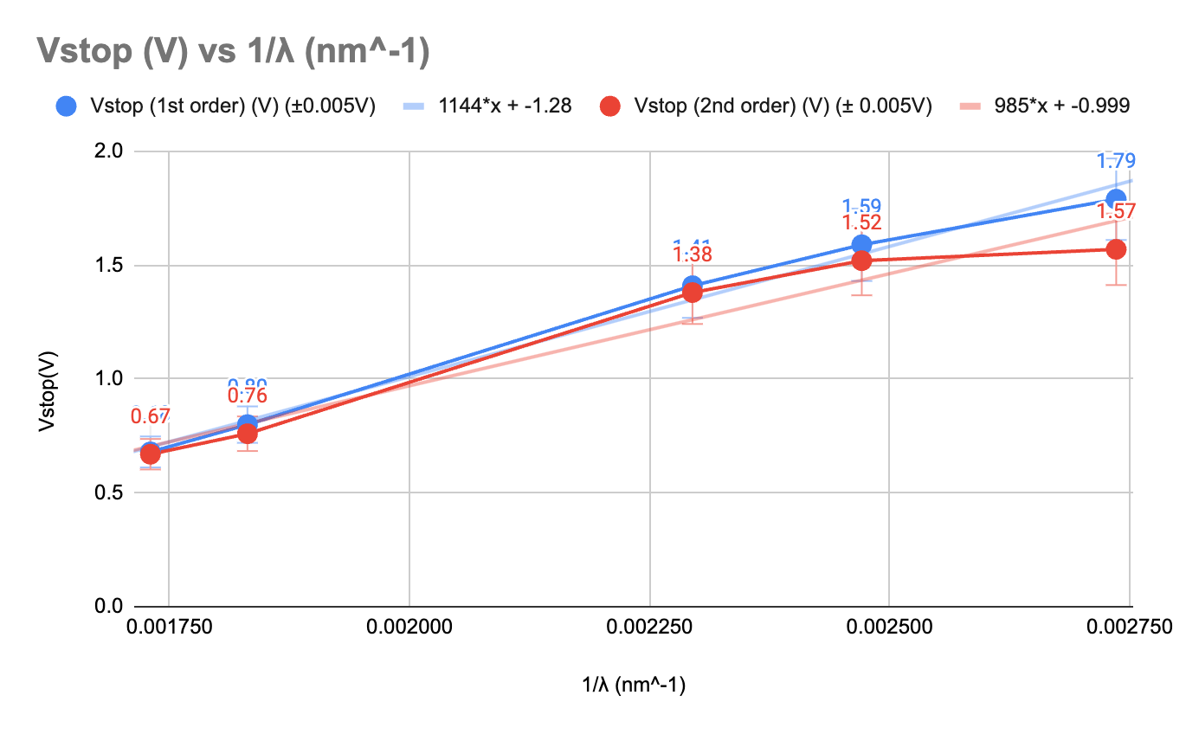
Table 2: Graph comparing the first order and second order voltages. Includes slope, error bars, and trendlines.

 | Slope (m) | Intercept (b)
1st Order | $1144 eV⋅nm±12.584 eV⋅nm$ | $-1.28 eV±0.014 eV$
2nd Order | $985 eV⋅nm±53.19eV⋅nm$ | $-0.999 eV±0.0539 eV$

Planck’s Constant (First Order)
$hc=Slope$
$h_{1}=\frac{1144 eV⋅nm}{2.997925×10^{17} \frac{nm}{s}}$
$h_{1}=3.816×10^{-15}eV⋅s ± 4.198 x 10^{-17}$eV$⋅s$

Planck’s Constant (Second Order)
$hc=Slope$
$h_{2}=\frac{985 eV⋅nm}{2.997925×10^{17} \frac{nm}{s}}$
$h_{2}=3.2856×10^{-15}eV⋅s$ ± 1.774 x 10⁻¹⁶ eV

Planck’s Constant (Average)

$h_{avg}=(3.2856×10^{-15}eV⋅s +$ $3.816×10^{-15}eV⋅s$) / 2
Uncertainty = ($4.198 x 10^{-17}$$eV⋅s$ + $1.774×10^{-16}eV⋅s$)

h_{avg} = 3.5508 x 10^-15 $eV⋅s$± 2.1938 x 10⁻¹⁶ $eV⋅s$

Work Function (First Order)

$eV_{stop}=KE_{max}$
$eV_{stop}=\frac{hc}{λ}-ϕ$ (y = mx + b form)
$ϕ=b =1.28 eV±0.014 eV$

Work Function (Second Order)

$eV_{stop}=KE_{max}$

$eV_{stop}=\frac{hc}{λ}-ϕ$ (y = mx + b form)

$ϕ = b=0.999 eV±0.0539 eV$

Work Function (Average)

$ϕ=\frac{(1.28 eV ± 0.014 eV) + (0.999 eV ± 0.0539 eV)}{2}$
$ϕ=1.1395 eV±0.0679 eV$

Planck’s Constant Percent Error

$\%error=|\frac{(3.5508 x 10^-15 eV⋅s ± 2.1938 x 10-16 eV⋅s)-(4.14×10^{-15}eV · s) }{3.5508 x 10^-15 eV⋅s ± 2.1938 x 10-16 eV⋅s}|×100\%$
$\%error=16.59\%±6.178\%$

Analysis and Calculations
By comparing the obtained values of h with the accepted value ($h=4.14×10^{-15} eV · s$), the values are not within the expected range. This is a result of the uncertainty obtained conducting the experiment. Even by adding or subtracting the uncertainty, the obtained value is still unable to reach h.

The stopping voltages for the first order lines compared to the second order lines are relatively similar with minimal differences. This makes sense because the energy of the photons for a specific frequency of light should remain constant regardless of its intensity or brightness. The observed differences could be due to experimental variations and the accuracy of the apparatus. This supports the Einstein/Planck Model of Light which suggests that light is made up of packets of energy called photons and its energy is related to its frequency. This is represented by the equation:

$E = hf = \frac{hc}{λ}$

Where “$h$” is Planck's constant, “$f$” is the frequency of light, “$c$” is constant for the speed of light, and “$λ$” is the wavelength of light.

Discussion/Conclusion
The threshold frequency of this apparatus is calculated with the equation:

$\frac{hc}{λ } = K_{e} + ϕ$

However, $K_{e} =0$ to find threshold frequency.

$\frac{hc}{λ } =ϕ$
$λ =\frac{hc}{ϕ}$
$λ =\frac{1240}{1.1395 eV ± 0.0679 eV}$
$λ =1088.1966±64.84$

Therefore, the threshold frequency is calculated to be:

$f_{0}=\frac{c}{ϕ}$
$f_{0}=\frac{3×10^{8}}{1088.1966±64.84}$
$f_{0}=275685000 hz ± 16426641.47 hz$

A bright light of a certain wavelength does not have the same total energy as a dim light of the same wavelength. The energy “$E$” of an individual photon of light is given by:

$E=hf$

Where “$h$” is Planck's constant and “$f$” is the frequency of light. However, the total energy of a light source also depends on the number of these photons it emits per unit time. A bright light emits a larger number of photons per unit time. Each of these photons has an energy $hf$, so the total energy output per unit time is much higher. In essence, for a bright light, there is a greater density of photons being emitted every second. A dim light emits a fewer number of photons per unit time compared to a bright light. The energy of each photon remains $hf$, identical to the photons from the bright light. However, because there are fewer photons being emitted every second, the total energy output per unit time is lower. While individual photons of a particular frequency have a fixed energy (as given by Einstein's equation), the difference in brightness between two light sources of the same frequency is due to the different numbers of photons they emit per unit time.

From our data, we observed consistent stopping voltages for both the bright and dim lines of the same colour. This observation underscores that the energy of released electrons is primarily determined by the light's frequency rather than its intensity, supporting Einstein's photoelectric equation and the concept of photons. Specifically, each colour, regardless of its brightness, has a consistent stopping voltage close in value between its first and second orders. Contrary to classical wave theory, which suggests that the energy of light is a continuous wave, our results align with the Einstein/Planck model of light. This model suggests that light energy is carried by discrete packets called photons, with each photon's energy determined by its frequency.

References

Serway, R. A., & Jewett, J. W. (2018). Physics for scientists and engineers (10th ed.). Cengage Learning.
The Photoelectric Effect. Toronto Metropolitan University.
Toronto Metropolitan University. (n.d.). Physics Lab Guide [PDF]. D2L. https://courses.torontomu.ca/d2l/le/content/795518/viewContent/5278918/View

